**Kingsway Christian College**

**Maths Department**

**Course**: Math Methods unit 3

**Assessment Task**: Test 3

**Student Name**: ________________________________________________________

**Date**: 11th & 12th  May 2017

**Assessment Score**: ____________ / 71

**Year Score**: __________________

**Comments**: ________________________________________________________

___________________________________________________________________________

___________________________________________________________________________

___________________________________________________________________________

___________________________________________________________________________

___________________________________________________________________________

___________________________________________________________________________

___________________________________________________________________________

___________________________________________________________________________

**Teacher signature**: ________________________________________________________

**Parent/ Guardian signature**: _____________________________________________

**Comments**: ________________________________________________________

___________________________________________________________________________

___________________________________________________________________________

___________________________________________________________________________

___________________________________________________________________________

**Math Methods Unit 3 Test 3 2017  
Anti - Differentiation**

**Resource Free Time: 50 minutes Marks: / 46**

**Only a formula sheet is allowed for this section. No calculator or notes allowed.**

**Question 1 (12 marks)**

Evaluate each of the following, showing all working. Leave all answers with positive indices.

1.  (1 mark)
2. $\int{3x{\left(x^{2}-2\right)}^{3}dx}$ (3 marks)
3.  (3 marks)
4.  (2 marks)

If it is given that $f\left(x\right)$ is continuous everywhere and that $\int_{4}^{10}{f\left(x\right)dx= -10, }$ find:

1. $\int_{1}^{3}{f\left(3x+1\right)dx }$ (3 marks)

**Question 2 (15 marks)**

Evaluate the following, showing full working.

1.  (3 marks)
2. $-3\int_{π}^{2π}{\cos\left(3x\right)dx}$ (3 marks)
3.  (3 marks)
4. $\frac{d}{dx}$ $\int_{4}^{x²}{\frac{2}{3t^{3}-1} dt}$ (3 marks)
5. $\int_{1}^{2}{\frac{d}{dx}\left(\frac{x³}{x^{2}+1} \right) dx}$ (3 marks)

**Question 3 (3 marks)**

The derivative of  is given by  . Given that  , find an expression for  .

**Question 4 (3 marks)**

The area labelled *B* is two times the area labelled *A*. Express *b* in terms of *a*.

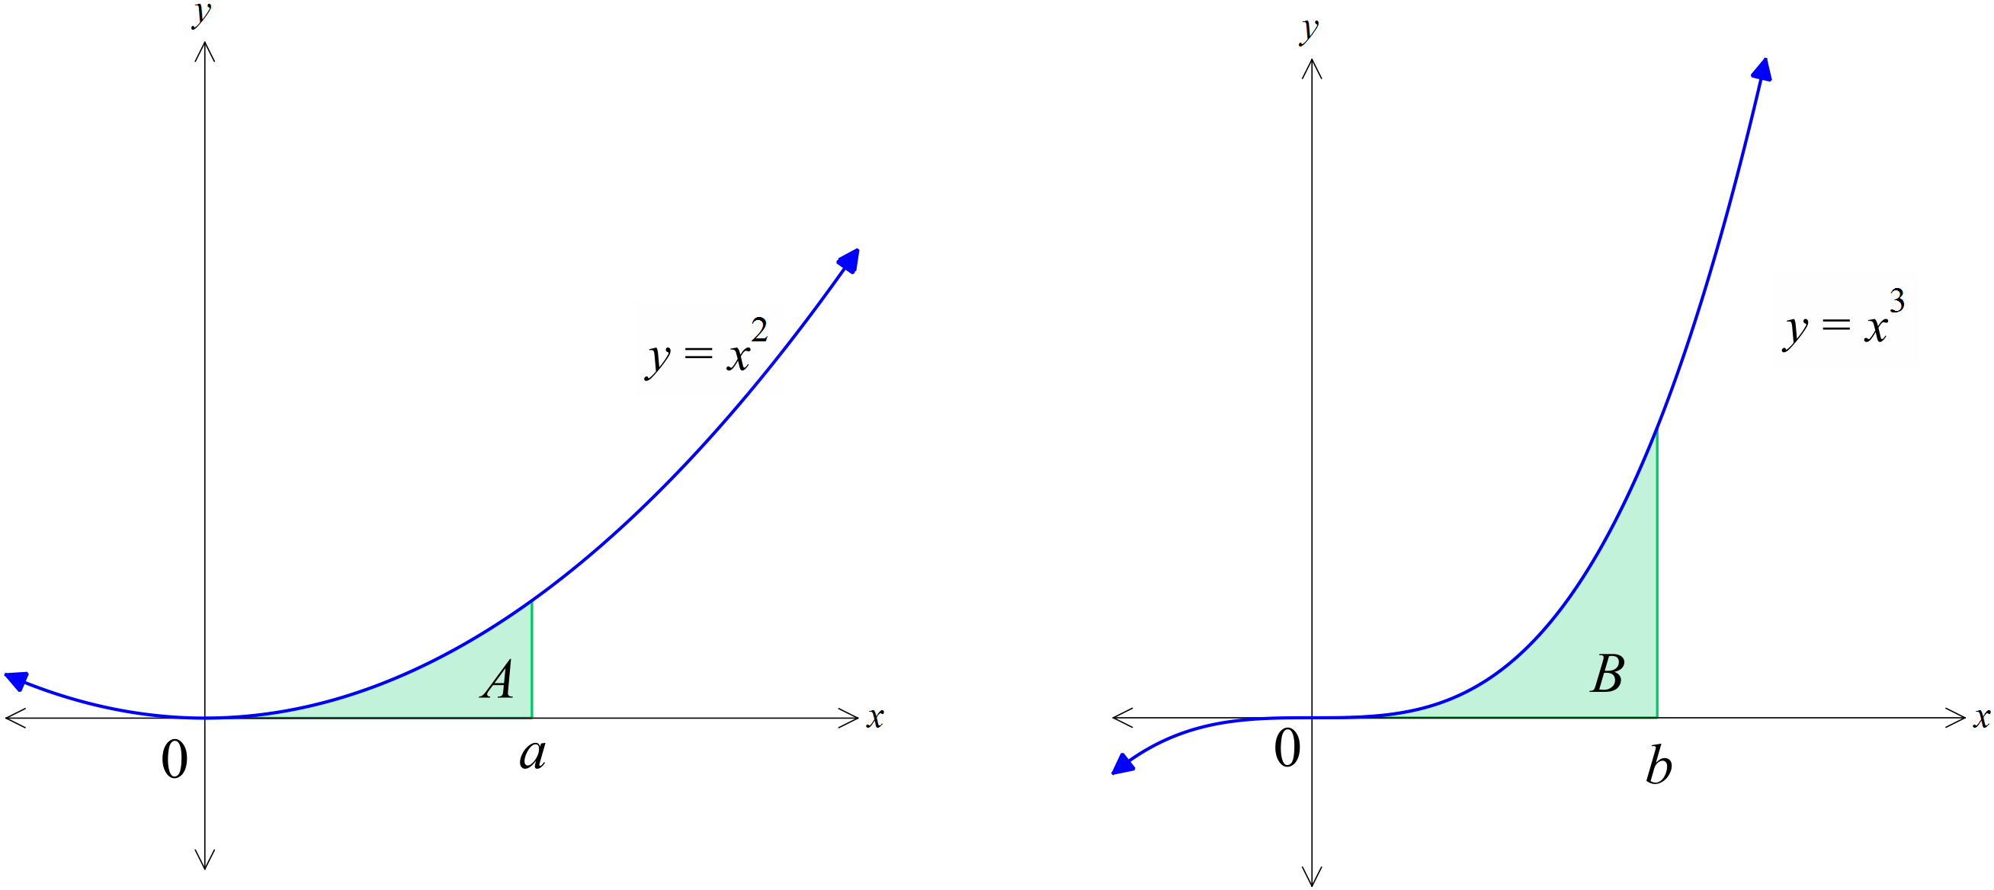

**Question 5 (3 marks)**

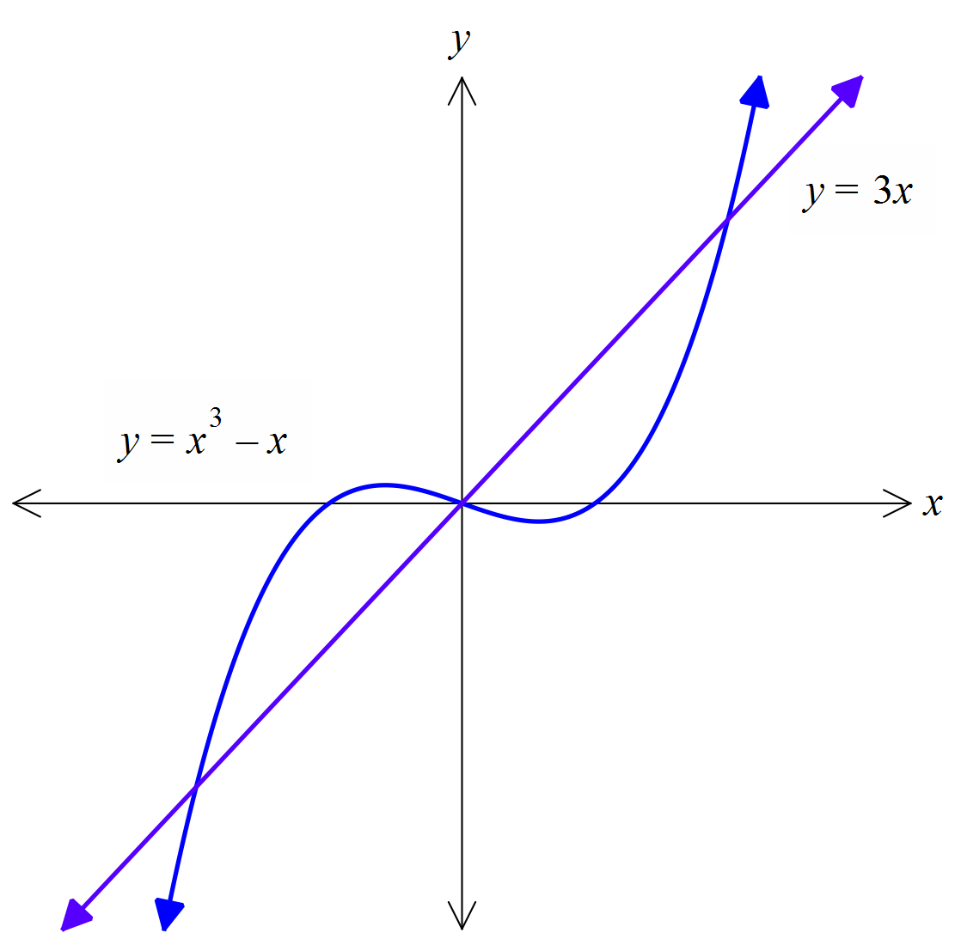Find the exact area bound by the two curves shown below.

**Question 6 (4 marks)**

Determine the function *y* given that 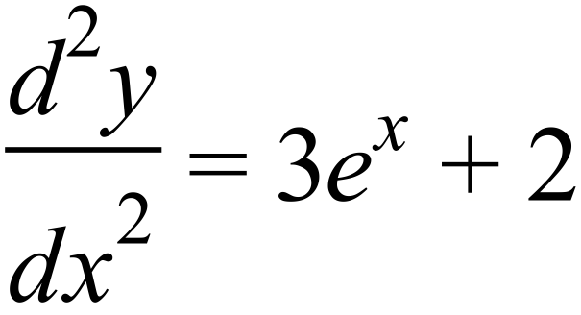 and 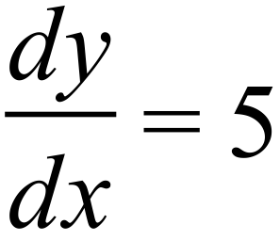 when *x* = 0 and 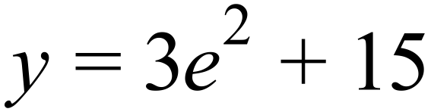 when *x* = 2.

**Question 7 (6 marks)**

The gradient function of  is given by  . Determine the values of *a* and *b* if  and  .

END OF PAPER 1

EXTRA PAGE FOR WORK OUT